|  |  |  |  |  |  |
| --- | --- | --- | --- | --- | --- |
| Date | December 14,2022 | | | Tester Name | Syed Shahabuddin |
| Environment | Penfax - Test | | | Login used |  |
| Operating System | Windows | Version: | Update: | | |
| Software Used | Edge | Version: | Update: | | |
| Select Software | Version: | Update: | | |
| Release version | 22.4.1 | | | | |
| Title | E23.02 - Process Investment transaction Batch | | | | |
| Test Type | Regression | | | | |
| Test Scenario | Process investment transaction Batch | | | | |
|  |  | | | | |
| Expected Results | Weekday- batch will run successfully  Weekend- batch will succeed, but say not a pepp business day  Stat holiday, batch will succeed, but say not a pepp business day  Reports will generate in separate batch & capstock available within PIT for both monthly and adhoc payments. | | | | |
| Pass/Fail | Pass | | | JIRA# | N/A |

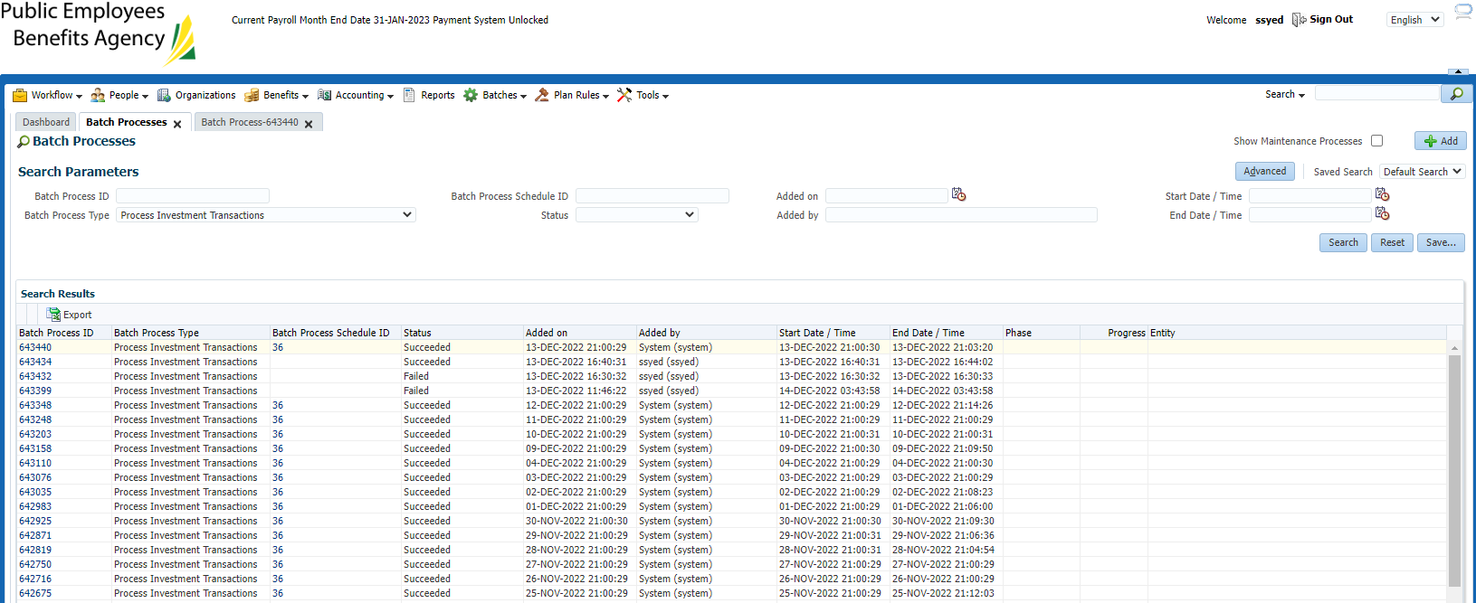

Stat Nov 11:

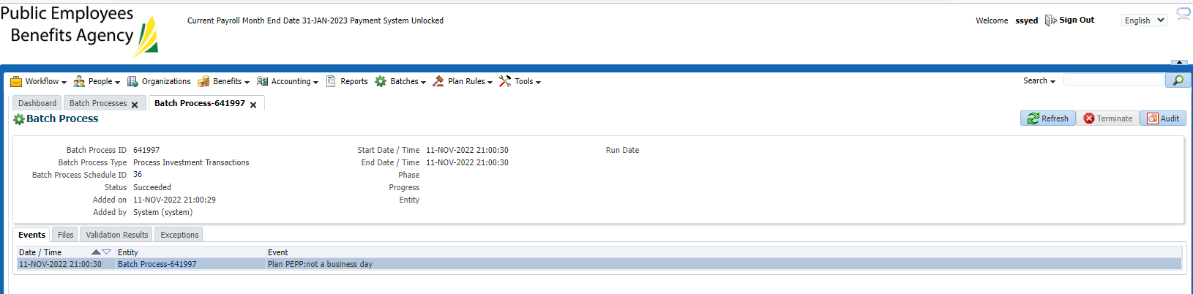

Weekend Dec 11:

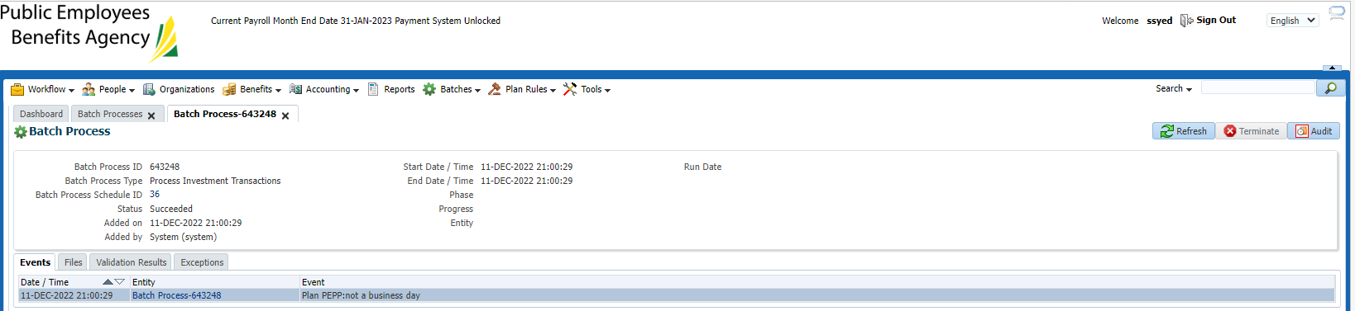

Weekday Dec 12, batch status succeeded and the reports ran in the below events.

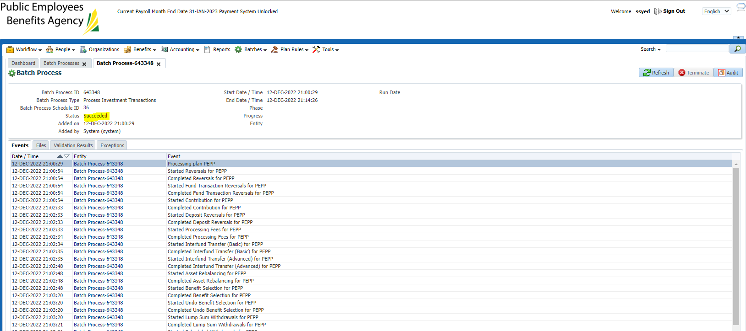

Sept 6 – Capstock report generated

